EXHIBITORS MANUAL

Event: ATIMIA CONFERENCE 2017
Date: 4-5 October 2017
Venue: Maslow Hotel, Sandton

Exhibition Build-up:

Custom Stands: Monday, 03 October 07:00 – 20:00
Exhibitors Dress Stands: Monday, 03 October 13:00 – 18:00

Exhibition Hours:

Wednesday, 4th October: 10h00 – 18h00
Thursday, 5th October: 11h00 – 13h00

Exhibition Breakdown:
Commences Thursday, 5th October 13h30 – 20:00
All display material to be removed by the completion time to allow for deconstruction of the shell scheme.

Deadline date for submission of orders and compulsory indemnity forms
Tuesday, 8 Sept 2017

CONTENTS
Useful Contact Details 3
Section 1 - Notice of Intent Form 4
Section 2 – Exhibitor Checklist 5
Section 3 – Compulsory Indemnity Form 6
Section 4 – Fascia Board Form 7
Section 4 – Floor-plan 8

GENERAL INFORMATION

1. EXHIBITOR PACKAGE 9

2. STAND CONSTRUCTION
Carpeting 9
Shell scheme walls 9
Fascia boards and fascia names 9
Fixing display materials 9
Constructed / designer stands 9

- VENUE INFORMATION
Access Parking 10
Deliveries 10
Access to the loading bay 10
Internet Connectivity 10
Cleaning 10
Construction Work 10
Plumbing 10

- HEALTH AND SAFETY
Aisles 10
Insurance 10
Vehicle Display 11
Electrical Hire and Supply 11
Fire Regulation 11

5. SPECIAL TERMS AND CONDITIONS
Compulsory Indemnity Forms 12

6. ACCOMMODATION 12

- SECURITY
Safety Sail 12

8. Pre-Package Stands 12

DESIGNING YOUR OWN STAND 13

9. CONTRACTORS TERMS AND CONDITIONS 14

10. PANEL MEASUREMENTS 15

Conference Organiser: Dana Benson Director of Conferences & Sponsorships
USEFUL CONTACT DETAILS
Tel.: +1-605-582-7058
E-mail: Dana.Benson@atmia.com

Exhibition Coordinator: Portia Mogashoa
Compex
Cell: +27 (0)63 692 2884
E-mail: portia@compex.co.za

Venue: Maslow Hotel, Sandton
Tel.: +27 (0)10 226 4600

Section 1
NOTICE OF INTENT – FLOOR SPACE ONLY EXHIBITORS

All exhibitors with FLOOR SPACE ONLY or DESIGNER stands must complete the following form and return it to Compex. Failure to complete the form will result in the organisers prohibiting build-up in terms of the Safe Working Practices Act.

We advise that the following contractor has been appointed on our behalf to erect the above stand and/or install electrical equipment. We also confirm that they have read and understood and agree to abide by the relevant regulations issues.

APPOINTED CONTRACTING CO

CONTACT PERSON

CONTACT NUMBERS TEL.: FAX
CELL:
E-MAIL:

BRIEF DESCRIPTION OF WORK TO BE CARRIED OUT

PLEASE FORWARD A COPY OF ALL DRAWINGS AND FULL DETAILS OF ANY ELECTRICAL WORK.

Signed for Exhibitor Date
Signed for Contractor Date
Signed for Organiser Date

PLEASE EMAIL SIGNED FORM BACK TO: portia@compex.co.za
Before the deadline: 8 September 2017

ADDITIONAL FURNITURE ORDERS:
Please fill in order form and return by: 8 September 2017

4 WEEKS IN ADVANCE OF THE SHOW
Section 2
EXHIBITOR CHECKLIST

- Ensure all stand payments due have been paid. Bank account details listed on the invoice.
- Know your stand number and location on the floor-plan.
- Create a timetable for your staff to co-ordinate stock, equipment delivery and removal.
- Circulate a list to all staff with dates and times, detailing whom will be on site.
- Order your stand furnishings and services via the Compex online ordering system.
- Submit Compulsory Indemnity form.
- Submit your company name as it should appear on the fascia board, to the exhibition organisers.
- Arrange for delivery/shipping of literature, equipment and display units.
- Make sure invitations to visit the stands have been included in all correspondence with customers.
- All design for floor space only stands must be submitted to the organisers who reserve the right to reject a design, which unreasonably obscures or affects nearby exhibitor stand in any way.
- All stand designers and floor space only exhibitors must complete the Notice of Intent form.

10 DAYS IN ADVANCE TO THE SHOW

- Prepare for set-up of exhibition stand.
- Prepare tool kit for all items necessary to set up stand and perform emergency repair of display units and equipment.
- Check supply of order books, scratch pads, business cards, pencils, sales manual, tape, screws and tacks.
- Organise service payment and deposit into the relevant bank account – no payment, no services.
- Ensure that enough exhibitor badges have been ordered for all the staff required to man the stand.
- Hold a pre-show meeting with stand personnel to review objectives, responsibilities and the lead retrieval system.
- Plan post-show follow-up activities.
- Submit Compulsory Indemnity Form

DURING BUILD-UP AT THE SHOW

- Review a proforma invoice/order forms for items ordered.
- Pick up exhibitor badges from the Organisers Office.

Stand #: __________
Section 3
COMPULSORY INDEMNITY FORM
Exhibitor: _________________________

INDEMNIFICATION

In terms of various pieces of legislation including but not limited to the Occupational Health and Safety (OHSACT), Construction Regulations, SANS 0400 National Building Regulations, Disaster Management Act, Events Bill, Regulation of Gatherings Act – No 205 of 1993, Basic Conditions of Employment Act, and EMS City Bylaws the exhibitor:
- hereby confirms that all of its employees, agents and/or contractors/sub-contractors acknowledge the legislation applicable within the Republic of South Africa,
- recognises the inherent hazards that exist during the setup of, the exhibition itself and the breakdown of the exhibition, and enters the property entirely at his/her own risk and therefore the Exhibitor waives any claim of whatsoever nature against Complete Exhibitions, its employees and/or agents in respect of any loss, damage and/or injury whether same is the result of any negligent act or omission on the part of Complete Exhibitions, its employees, agents and/or mandatories or other independent contractors or by a third person or by way of defective equipment or materials supplied by the company, and further;
- the Exhibitor hereby indemnifies Complete Exhibitions, its employees and/or agents against any claims from the Contractor’s employees and/or any other person, arising and being caused in the manner set out above.

I, Insert name of individual, representing Insert exhibiting company name [the Exhibitor], do hereby declare that I acknowledge having read and understood the above statement and furthermore, confirm that I am duly appointed to sign on behalf of the exhibitor and agree to abide by these conditions.
Exhibitor Name | Exhibitor Signature
Date | Signed at
Compex Representative | Compex Signature
Date | Signed at

PLEASE EMAIL SIGNED FORM BACK TO: portia@compex.co.za
Before the deadline: 08 September 2017

Section 4
FASCIA NAME

Standard fascia names will be provided for all shell scheme stands. Should you wish to order a printed logo for your fascia, please contact Portia for a quotation.

On the blocks below, please provide your company name as you would like written on the fascia board for your stand:

Special notes:

………………………………………………………………………………………………………………...........

………………………………………………………………………………………………………………...........

………………………………………………………………………………………………………………...........

………………………………………………………………………………………………………………...........

………………………………………………………………………………………………………………...........

………………………………………………………………………………………………………………...........

………………………………………………………………………………………………………………...........

Email signed form back to portia@compex.co.za before deadline date:
08 September 2017

Section 5
FLOORPLAN

NB:

Occupied

Booth Company

01 HID Global Corporation
02 TMD Security Gmbh
04 Paycorp Holdings - ATM Solutions Group
05 Spark ATM Systems
07/08 Reslam
09 KAL
13 Oberthur Cash Protection

1. | EXHIBITOR PACKAGE  - Structure of the basic booth/shell scheme  - 1 x fascia board and company name in English (no logo) an average of 20 letters.  - 1 x 15 amp power point, shared power  - A double fluorescent light fitting  - Standard trestle tables and 2x chairs per stand.  Where the exhibitor does not require a shell scheme, floor space only plus one single phase distribution board will be supplied.
2. | STAND CONSTRUCTION  Carpeting  Exhibition hall is carpeted. To increase the visual impact of your stand, you may order specific coloured carpeting to co-ordinate with your corporate colours or stand theme.  Shell Scheme Walls  Each wall is made up of 1m panels, supported within an aluminium frame. Panels are made out of compressed styrene.  The internal dimension of the stand are slightly less than the external dimension, thus the distance between the walls of a three meter stand is 2 970mm, and each panel has an internal /visible width of 980 mm and a height of 2 414mm.  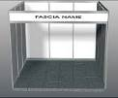  The aluminium frame protrudes by 30mm from the walling, thus the walling and the frame are not flush. The fascia boards are 400 mm deep with an inner ‘usable’ area of 300mm. The internal width of the Fascia board, from side to side in the case of a 3m x 3m stand, is 2 960mm.  Fascia Board and Name  The name of the exhibiting company, as provided by the exhibitor, will be displayed on the fascia board on all open sides of a shell scheme stand. Names will be produced in standard letters. Fascia board logo may be ordered at an additional charge. Failure to submit your fascia name by the stipulated submission date may result in the exhibition organisers using their own discretion in producing your company name.  Fixing Display Material  Display material may be fixed to the exhibition stand walls by means of double sided tape or sticky-backed Velcro. You must provide this for your own stand. Nails, screws or permanent adhesives may not be used, nor any other mechanism that will cause damage to the exhibition boards. Hooks will be provided to suspend heavier objects. Under no circumstances can anything be attached to any surface or wall within the convention centre.  Constructed / Designer Stands  Prior approval has to be obtained from Compex one month before the event if you wish to have a ‘designer’ or custom built stand constructed.  All ‘designer’ or custom built stands have to comply with the following parameters:  - No construction over aisles is allowed.  - No construction may be attached to any wall or ceiling in the venue.  - No bolt, nail, screw, glue, adhesive or other fixing may be used to fix any structure or display into or on the venue infrastructure, in any manner.  - An electrical certificate of compliance must be submitted to the On-Site Exhibition Co-ordinator before the completion of build-up.  - No structure above 2.5m high is allowed under any circumstances whatsoever, unless a structural engineer certificate is issued.  Exhibitors or their contractors are responsible for cleaning and removing all rubbish and discarded material arising from the construction or dismantling of a stand.
3. | VENUE INFORMATION  The Exhibition will be held at the Maslow Hotel, Sandton  Access Parking  Parking will be available at the venue. When you get to the main gate, please mention to the security that you are attending the ATMIA Conference in the conference hall and they will let you through. For the purpose of unloading, all vehicles must use unloading facilities in the loading area at the venue.  Deliveries  Neither the Organisers nor the Venue will accept deliveries on behalf of exhibitors. Neither the venue nor organisers can be held responsible for goods that arrive early or which are left after the official breakdown period of the exhibition. The costs of disposing of any such items will be done at the expense of the exhibitor concern.  Access to the loading bay:  Exhibitors can off load their goods from the commercial vehicles and private cars. Please ensure that goods are off loaded and vehicles are then removed and parked. Any vehicle parked in the loading bay will have their wheels clamped, and standard penalties will apply.  No Unloading or Loading of any equipment/materials is allowed via the Front Entrance of the Convention Centre.  Internet Connectivity Wireless  The venue has Wi-Fi internet coverage in all the major public areas, such as the conference centre. Your lap top or handheld device requires either built in support for Wi-Fi, or to be equipped with a Wi-Fi network card  Cleaning  The exhibition area will be cleaned after all displays have been erected. The exhibition venue will be cleaned nightly. The organisers will not clean the stands (dusting of shelves etc.) because of the increased risk of damaging products or demonstration models or material.  Construction Work  If constructions work, i.e. carpentry, painting, sign writing etc. is to take place within the venue all necessary precautions must be taken to avoid any damage to the physical structure of the venue, or its fixtures, fittings and carpets. Any damage caused by, or on the behalf of, an exhibitor, will be for the account of the exhibitor.  Plumbing  No plumbing is available in the exhibition area. In addition, the venue does not allow large quantities of water to be used in exhibit displays, such as in fountains and fish tanks etc.
4. | HEALTH AND SAFETY  Aisles  Clear aisle space must be maintained during setup and breakdown or exhibitions as well as for the duration of the actual exhibition.  The minimum aisle space applicable to all exhibitions is 3 (three) meters.  Insurance  Exhibitors are strongly urged to ensure that they have adequate insurance cover for all exhibits, equipment and display material. Neither Compex nor the Convention Secretariat may be held liable for any damage caused by an exhibitor or their sub-contractors, or any losses suffered due to any cause whatsoever.  Vehicle Display  The Convention Centre must be notified of any intention to bring vehicles into the exhibition hall on confirmation of booking or 1(one) month in advance.  Should the venue permit your request to bring the vehicle inside, please finalise the process of driving in, with them. Please note that special conditions will apply:  - The vehicle must be tested for emissions and proof of test to be submitted to the Convention Centre, before the vehicle have access to the venue.  - Vehicles brought and removed from the venue should make provision that they commence build up and breakdown as allocated in the set up times.  - Owners and drivers of vehicles moving on the ramp and inside the exhibition hall will be liable for any damage to the structure, fittings and fixtures  - The vehicle may not be filled with more than a ¼ tank of fuel  - Battery must be disconnected for the duration of the event  - A drip tray must be provided and placed underneath the vehicle for any oil leaks  - A fire extinguisher must also be positioned on the stand  Vehicles may not be switched on and moved during the event hours.  Electrical Hire and Supply  All shell scheme stands will receive a single 15-amp power point and a double fluorescent light. An exhibitor occupying two units will thus receive two plugs and two lights. This is shared power, and we strongly advise you to hire your own dedicated DB board if you intend to use heavy electrical equipment.  Please note that the standard SA power supply is 220/230volts AC 50 Hz. US made appliances of lesser voltage will need their own power supply units / transformers. Plug points take two- or three- pronged round pinned plugs. 3-phase power is only available with prior arrangements, and the payment of an additional fee.  Any exhibitor making their own electrical installation (such as on a custom stand), must hand an Electrical Certificate of Compliance (COC) to the On-Site Exhibition Co-ordinator at the conclusion of Build Up. We can only accept this certificate if it was obtained in a valid manner, i.e. a certified electrician inspected the installation on site. Failure to provide a valid certificate will result in supply of power to the stand being terminated without further notice.  **Due to the strict safety regulation governing the Maslow Hotel, please take note of the following:  - No twin flex is allowed under any circumstances whatsoever.  - All plugs, cable ties, transformers, distribution boards and other fittings must be SABS approved.  - No joints or trailing cable is acceptable.  - All wiring systems must be insulated flexible cables with copper conductors that have a minimum cross section area of 1.5mm² (3 core cab tie).  - All fluorescent lights must be earthed. Transformers must be mounted on the exhibition structure and may not be placed on the floor.  - Lighting must be looped from fitting to fitting with all terminals being secured and sealed.  Fire Regulations  - No highly combustible material such as hessian, straw, paper, polyurethane, etc. may be used in the construction of a stand or within the exhibition display.  - No solid ceilings may be used without prior permission. All draping must be treated with fire retardant spray, and a valid certificate attesting to this must be handed to the On-Site Exhibition Co-ordinator during build-up.  - No dangerous chemicals or gas cylinders are permitted. In addition, no pyrotechnics in any form, and no open flames are permitted.

5. | SPECIAL TERMS AND CONDITIONS  Compulsory Indemnity form  It is every exhibitor’s responsibility to ensure that they read, sign and return the Compulsory Indemnity form. This is a compulsory requirement. No exhibitor will be permitted to exhibit unless the form is signed.
6. | ACCOMMODATION  Accommodation for the duration of the Conference is at account of the exhibitor. You may visit the conference website for a list of recommended hotels in the area and bookings, or the venue website.
7. | SECURITY  Although the exhibition hall will be locked each night and there will be security guards on duty, exhibitors remain responsible for any material on their stands. The organisers, venue or any sub-contractor will not accept any liability for any loss or damage. It is therefore of vital importance that exhibitors take all the necessary precautions to avoid any losses from occurring. Particular attention must be taken in regards to valuable items such as cellular telephones, laptops, video cameras, plasma screens, or any portable electronic devices. Exhibitors are advised to ensure that their products and equipment are covered by their own insurance. Additional Security Guards dedicated to specific stands may be arranged. All costs incurred are for the specific exhibitor’s account.  Safety sail is available for hire; this innovative sail protects merchandise and equipment on display and prevents access onto the stand area outside show hours. The sail clips onto the opening on the stand shell scheme, left and right and front top to bottom. The sail takes 5 minutes to set up and secured locks with your own key. This is definite deterrent to prevent unauthorised persons from entering your stand after the show hours. If you wish to order a sail, please contact Compex directly.
8. | PRE-PACKAGED ‘DESIGN STANDS’  If you want your stand to stand out, consider the optional extra of having a packaged designer stand built by Compex. These stands represent real value for money, as they have the look and feel of a designer stand at a fraction of the cost. Production of the graphic panels is included. Please visit Compex website: www.compex.co.za to design your own package stand online and get an instant estimate, or you may contact Nicole East on +27(0)82 857 3762 or : Nicole@compex.co.za for pricing.

Section 6
DESIGNING YOUR OWN STAND

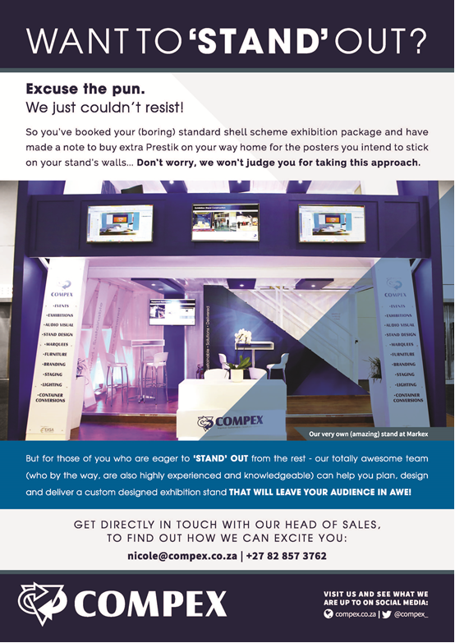

9. CONTRACTORS: TERMS AND CONDITIONS

Contractors shall ensure that work is executed in all respects in accordance with the requirements of the Occupational Health and Safety Act and its regulations, as amended and all statutory regulations applicable, including the keeping of proper records, production of test certificates and appointment of Competent Persons. It is therefore mandatory – prior to all scheduled exhibitions, that exhibition organisers, contractors and exhibitors take note of the following regulations. This agreement is binding on all sub - contractors engaged by the undersigned parties.
- All requirements of the Occupational Health and Safety Act 85 of 1993 and Regulations (as amended) shall be adhered to.
- Any other statutory requirements pertaining to the area of exhibition shall also be adhered to.
- Section 37 – Acts or omissions by employees or mandatories. Subsection 2 states that the employer shall be liable for any acts or omissions by any of his/their/its employees and/or mandatories, except if the parties have agreed in writing to the arrangements and procedures between them to ensure compliance by the mandatory with the provisions of this Act;
- When any activity during build-up and/or breakdown periods, is of such nature that it could cause injury to anyone, or damage to the environment, all reasonable practicable preventative measures shall be implemented to ensure the health, safety and/or impact upon the environment.
- No dumping of any hazardous chemical substances is permitted into any drains and/or waste bins. Same shall be disposed of in terms of the Hazardous Chemical Substance Regulations of the Occupational Health and Safety Act 85 of 1993;
- Should any chemicals, gases and/or substances be required to be used during build-up, breakdown and/or show periods then all relevant material safety sheets are required on site (where required in terms of the Act);’
- Be advised that this agreement places the onus on the mandatory to contact Compex in the event of inability to perform as per this agreement. However, reserves the right to unilaterally take any steps as may be necessary to enforce this agreement.
- All mandatories are to provide and ensure the correct use of personal protective equipment by their employees at their cost at all times.
- All mandatories are to maintain and ensure that all electrical apparatus and safety equipment is kept in a safe working condition at all times.
- In terms of Section 16 (3) of the Occupational Health and Safety Act no. 85 of 1993, no appointment(s) will relieve an Exhibitor (employer) to (the contractor or sub-contractor) of any responsibility or liability under this Act.

Please take note of the following guidelines:

Power/Electrical Supply
All electrical services, supplied by outside/third parties, must be in accordance with regulations as stipulated within the Health and Safety Act and must be accompanied by an original Electrical Certificate of Compliance, which must be handed to Compex on site, prior to the opening of the event.

10. PANEL MEASUREMENTS

TYPICAL 3M X 3M U-SHAPE STAND

Panel Artwork Sizes: 2414mmH x 974mmW
Visible Area Size: 2400mmH x 960mmW
Fascia Artwork Sizes: 313mmH x 2974mmW

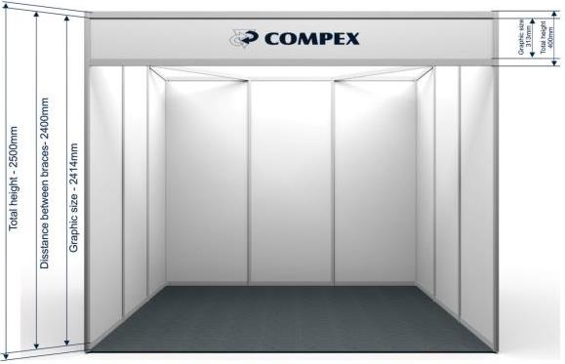

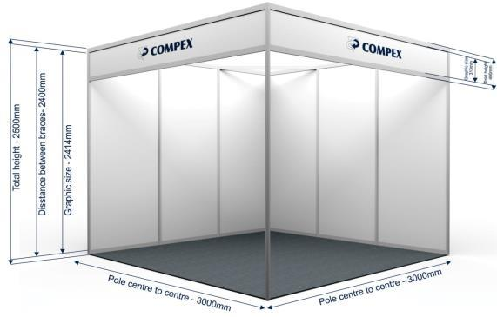
TYPICAL 3M X 3M CORNER STAND

