PRESS RELEASE
29th September 2021

NoteBond™ announces the launch of a newly patented ATM Cash Spoiling device that averts theft by dispensing specially formulated glue on the outer edges of the notes in the ATM cassette, leaving the central portion of the stack unbonded which means that the notes are unusable by criminals.
The significant benefit to ATM owners is that, if the glued notes are recovered, they can be presented to the Central Bank, who can then identify the notes and refund the value to the ATM owner.
NoteBond is able to combine DNA markers to our glue to assist in the identification of recovered notes.

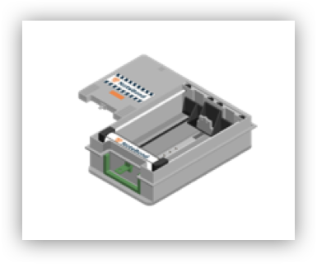
NoteBond™ has been designed to fit within the cassette, taking up the minimum possible space. NoteBond™ is inert when the cassette is not inserted. This removes the risk of accidental discharge.

We were passionate about designing a device, which would operate as intended, so we started from a blank page and examined each element of the system to optimise them.”
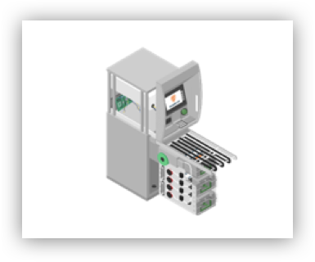
The focus is around three key areas:
- The detection systems
- The glue delivery mechanism
- The glue itself
We are excited to bring NoteBond™ to market, working in Partnership with ATM owners. The system has been in operation in mainland Europe for over two years and bank notes have already been repatriated by one of the Central Banks.
There has been a dramatic increase in physical ATM attacks over the past ten years, consisting mainly of ‘smash and grab’ or gas attacks.

These physical attacks typically result in significant damage to not just the ATM, but also to surrounding property and infrastructure.
By removing the prize, we are not just removing the crime, but we also hope to prevent this consequential damage as well.
NoteBond™ is owned and licensed by ASSI Global Limited in the UK. If you would like to find out more, please either visit our website: www.assiglobal.co.uk, or email us on: sales@assiglobal.co.uk

